
भारतीय जीवन बीमा निगम, जबलपुर मण्डल
LIFE INSURANCE CORPORATION OF INDIA, JABALPUR DIVISION

Tender for Various Gift Articles Category-02 : Annexure: - A
PLEASE QUOTE YOUR RATE/PRICE IN FOLLOWING SLABS FOR ARTICLES

S.No | Articles Name | Articles Picture | Specification | QUANTITY | Rate
01 | Vegetable Chopper  Cutter (Prestige by Judge) | 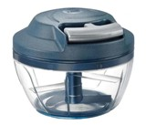 | Capacity: 450ml  Material: Plastic | UP TO 100
 |  |  |  | 101 to 500
 |  |  |  | 501 to 1000
 |  |  |  | Above 1000
02 | Hot Pot  Casserole with Lid (Cello Vista) | 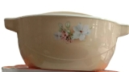 | 2500ml  Inner: Stainless Steel  Material: Plastic, PU insulated | UP TO 100
 |  |  |  | 101 to 500
 |  |  |  | 501 to 1000
 |  |  |  | Above 1000
03 | Hot Pot  Casserole with Lid (Cello Vista) |  | 1500ml  Inner: Stainless Steel  Material: Plastic, PU insulated | UP TO 100
 |  |  |  | 101 to 500
 |  |  |  | 501 to 1000
 |  |  |  | Above 1000
04 | Non-Stick Kadhai (Prestige by Judge everyday) | 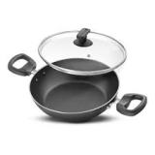 | Size: 26 cm  Capacity: 3.2L  Low Oil Cooking, Easy Clean, Cool Touch Back Lit Handel | UP TO 100
 |  |  |  | 101 to 500
 |  |  |  | 501 to 1000
 |  |  |  | Above 1000
05 | Non-Stick Kadhai (Prestige by Judge everyday) |  | Size: 22 cm  Capacity: 1.6L  Low Oil Cooking, Easy Clean, Cool Touch Back Lit Handel | UP TO 100
 |  |  |  | 101 to 500
 |  |  |  | 501 to 1000
 |  |  |  | Above 1000
(ALL RATES ARE EXCULISIVE GST)

Vendor Signature with seal

Cont---2---
---2---
06 | Sandwich Giller (Prestige Pro-Look) | 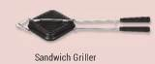 | Size: 14cm, SG-14 | UP TO 100
 |  |  |  | 101 to 500
 |  |  |  | 501 to 1000
 |  |  |  | Above 1000
7 | Pudding Set (La-Opala Classic) | 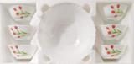 | Size: (6x10cm, 1x7cm 1set 7pieces)  Microwave Safe  Dessert Safe | UP TO 100
 |  |  |  | 101 to 500
 |  |  |  | 501 to 1000
 |  |  |  | Above 1000
8 | Lunch Box  (Lunch- Box Milton) | 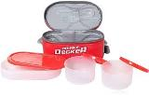 | With insulated jacket  3 container  Microwavable & leak-proof Tiffin | UP TO 100
 |  |  |  | 101 to 500
 |  |  |  | 501 to 1000
 |  |  |  | Above 1000
9 | Non-Stick Fry Pan (Prestige by Judge every day) | 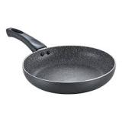 | Size: 22cm,1.5L | UP TO 100
 |  |  |  | 101 to 500
 |  |  |  | 501 to 1000
 |  |  |  | Above 1000
10 | Gas-Lighter (Crystal Aristo) | 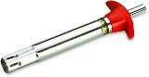 | Stainless Steel | UP TO 100
 |  |  |  | 101 to 500
 |  |  |  | 501 to 1000
 |  |  |  | Above 1000
11 | Omni-Tawa (Prestige by judge every day) | 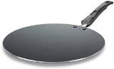 | Size: 25cm  Aluminum, Low Oil Cooking | UP TO 100
 |  |  |  | 101 to 500
 |  |  |  | 501 to 1000
 |  |  |  | Above 1000
12 | Coffee-Mug (La-Opala by  Diva) | 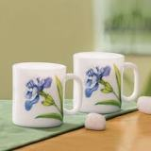 | 2 pieces set | UP TO 100
 |  |  |  | 101 to 500
 |  |  |  | 501 to 1000
 |  |  |  | Above 1000
13 | Non-Stick Kadhai and tawa set (Prestige by Judge deluxe) | 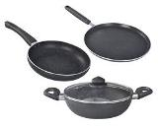 | 3 pieces set | UP TO 100
 |  |  |  | 101 to 500
 |  |  |  | 501 to 1000
 |  |  |  | Above 1000

Remark :-(All Rates Are Excluding GST)

Signature of vendor and Seal

